**Flow Chemistry - Augmented Reality**

**Motivation:** The current small molecule API workforce is rapidly moving from batch to continuous flow reactor designs. This has left a highly technical workforce untrained in modular, continuous flow technology. These modules are designed to introduce users to the basics of designing, assembling and operating flow chemistry platforms.

**Objectives:**

1. Learn engineering heuristics to convert batch unit operations to flow
2. Become familiar major components for custom flow systems
3. Assemble/construct flow reactors
4. Operate flow reactor/separation

**Approach:** by the end of this mini-course, you will have designed, constructed and operated a continuous flow reactor (Figure 2). This will be done by completing 5 modules that will culminate in their combined operation. The proposed methods (and figures below) are heavily adapted from published work by Britton and Jamison. Please refer to their work for detailed, step-by-step procedures.

Britton, J.; Jamison, T. F., The assembly and use of continuous flow systems for chemical synthesis. *Nature Protocols* **2017,** *12* (11), 2423-2446.

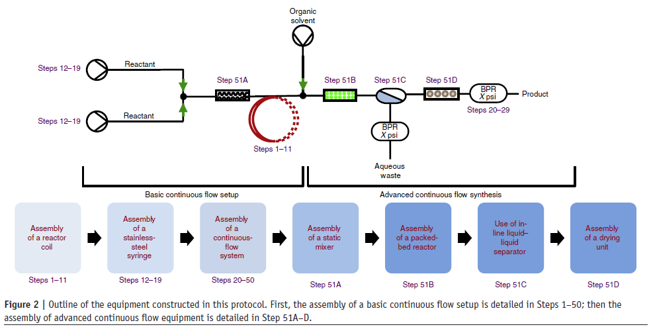

(3)

5

4

3

2

1

**Module 1: Pumping**

When selecting pumps, there are a multitude of criteria to consider. This module will assist in identifying the proper pump(s) for a particular application.

Selection Criteria

* Flowrate
* Pressure
* Phase(s) (compressibility, settling)
* Temperature
* Chemical compatibility

Types of Pumps

* Syringe (HA PHD Ultra)
* Continuous syringe (VICI M6)
* Positive displacement (Elveflow)
* HPLC (Knauer 4.1s)
* Peristaltic
* Gear
* Roughing/Vacuum
* Mass Flow Controller (Brooks/Bronkhorst)

|  |  |  |  |  |  |
| --- | --- | --- | --- | --- | --- |
| Pump | Operating Principle | Flowrate | Pmax | Advantages | Disadvantages |
| HA PHD Ultra |  |  |  |  |  |
| VICI M6 |  |  |  |  |  |
| Elveflow |  |  |  |  |  |
| Knauer 4.1s |  |  |  |  |  |
| Peristaltic |  |  |  |  |  |
| Gear |  |  |  |  |  |
| … |  |  |  |  |  |

Note to programmer: we would like an ineractive selection guide that will provide pictures/animations of the operating principles along with relevant metadata for each device.

**Module 2: Mixing**

Mixing is often critical when 1) two streams initially come into contact, and 2) during a reaction to ensure proper heat/mass transfer. In this module you will choose and test a static mixer performance.

1. Select from the following two stream contactors

* Tee, Y, mixing tee, microfluidic chip,

1. Assemble a simple mixing set-up with:
   1. 2 x 10 mL syringes
   2. Tee
   3. Static mixer (Stamixco)
2. Leak test: load syringes with water, initiate flow, and check for leaks
3. Microreaction:
   1. load syringes with acid/base (see lab write-up for chemistry)
   2. set flowrate: 1.0, 0.1, and 0.01 ml/min.
   3. measure reaction products using in-line UV
   4. Repeat with other types of static mixers as desired (mixing Tee, Y, etc.)

Hints:

* Make sure there are no gas bubbles in the syringes
* Once the system is wet, it will take a few seconds to achieve hydrodnynamic steady state (i.e. pressure stabilizes)
* It will take 3-10 residence times (V/F) to for the reactor to operate at steady state (products stabilize)

 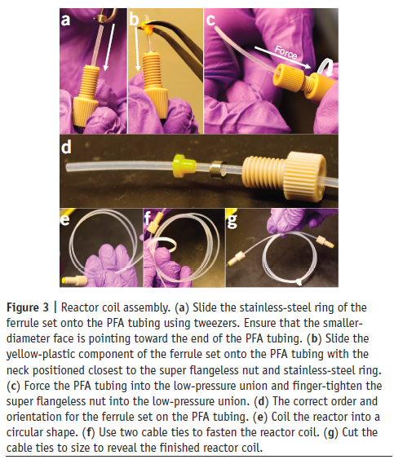 

Note to programmer: we would like to incorporate graphics (and videos) demonstrating the mixing within each device. After that, we would like to have a walkthrough to help the user construct a simple setup.

**Module 3: Tubular Flow Reactor**

In this module, you will construct a reactor coil and assemble it with a pump and back pressure regulator.

* Calculate the length of tubing required to achieve your desired residence time: ,
* Cut and assemble coiled tubular flow reactor with BPR
* Add back pressure regulator
* Set flowrates and test for leaks
* Advanced: perform RTD to confirm residence time and plug flow

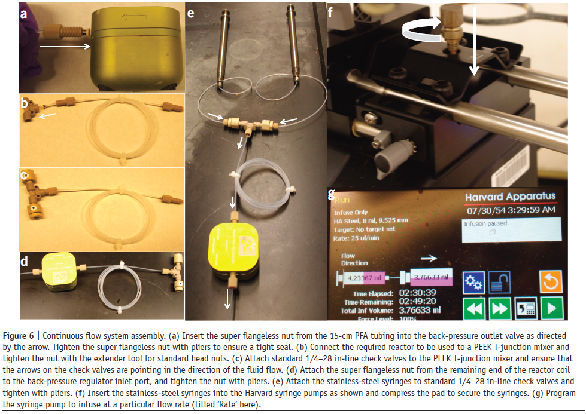

**Module 4: Packed Bed Reactor**

In batch, it is common to have a slurry mixture with the catalyst suspended in a liquid, and a gas phase reactant in the headspace or bubbled through.

Here, we will take that system and convert it to flow by identifying reaction conditions, filling a PBR, and assembling/operating the proper equipment.

* Assemble PBR that achieves a residence time of 1 minute.
* Pack PBR with 150 μm glass beads
* Leak test and wash PBR
* Performs ΔP study at 5 flowrates
  + Experiment: see CHE4402 procedure

In brevity, set the liquid flowrate and record the pressure drop (LabVIEW). Repeat this for the following flowrates:

F=0.01, 0.05, 0.1, 0.5, 0.25, 0.5, 0.75, 1.0, 2.0, 3.0, 4.0, 5.0 ml/min

Hint: wait for flowrate to stabilize

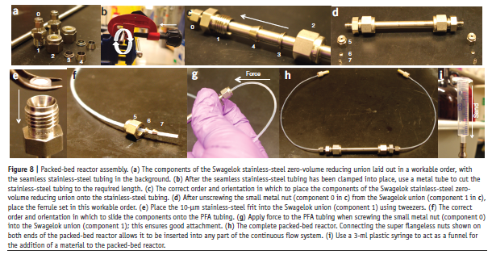

* Perform RTDs at 3 flowrates
  + Experiment: see CHE4402 procedure

In brevity, add the valve and RTD to the system and inject dye

F = 0.01, 0.1, 1.0 ml/min

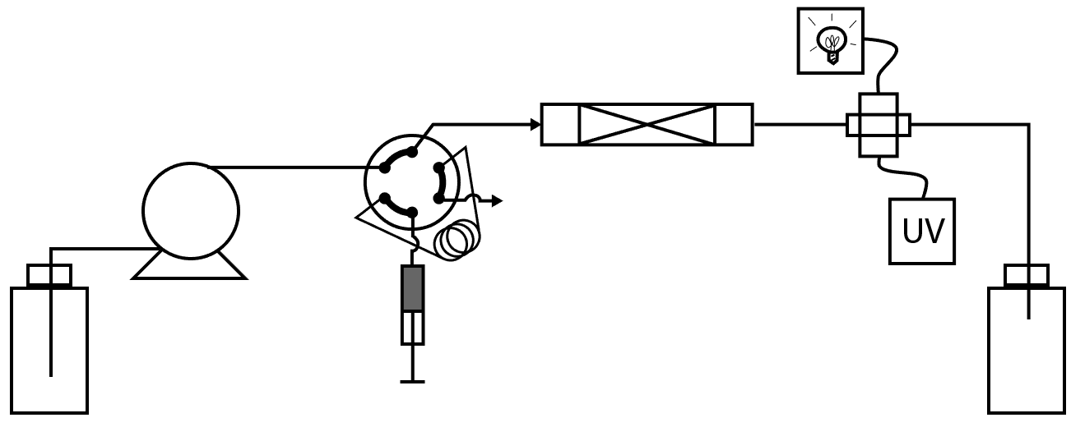

**Module 5: Liquid/Liquid Extraction/Separation**

* Classical batch extractions require solvent switching (mixing), and gravity separations (settling). Here, you will rapidly mix (static mixer) and quickly separate (membrane) in a continuous, scalable, manner.

Tasks:

1. Assemble the system: pumps, static mixer, phase separator
   1. Assemble the separator with the proper diaphragm and membrane

Follow the procedure of Britton and Jamison, 2017 Step 51C

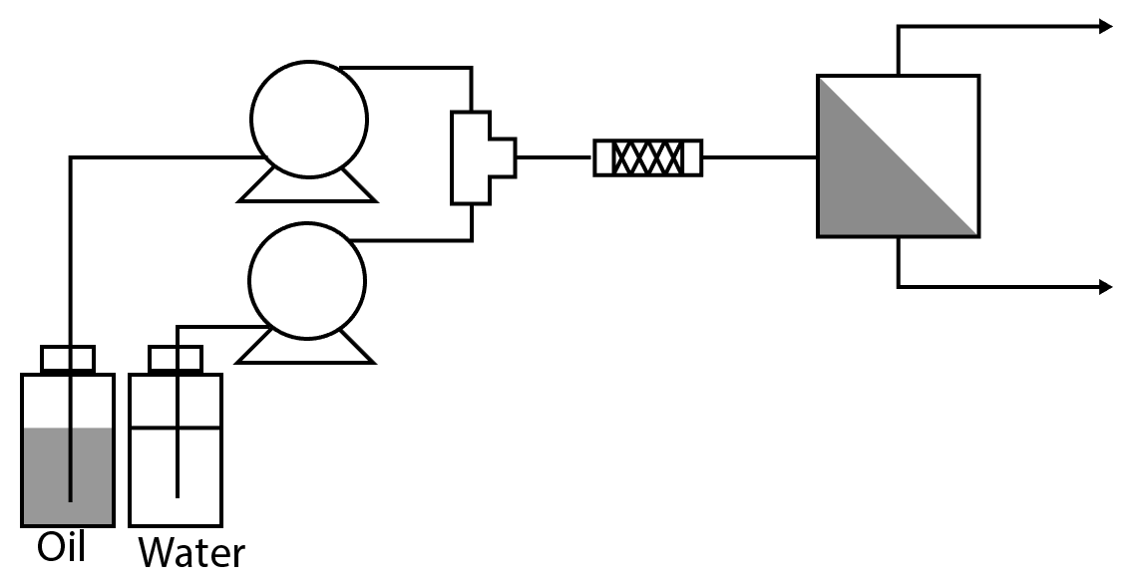

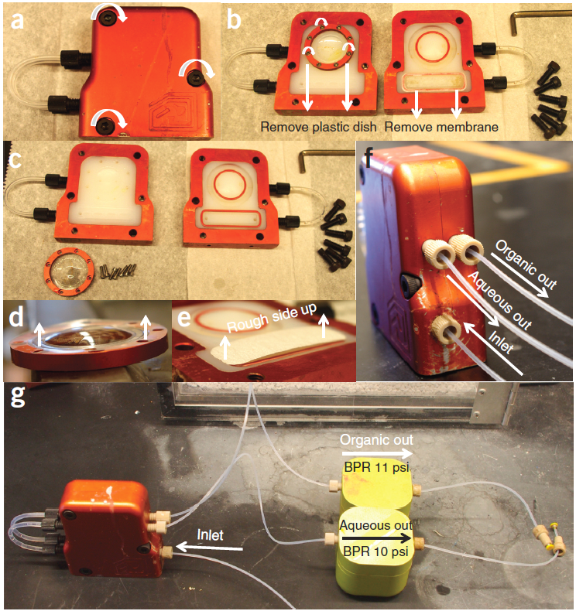 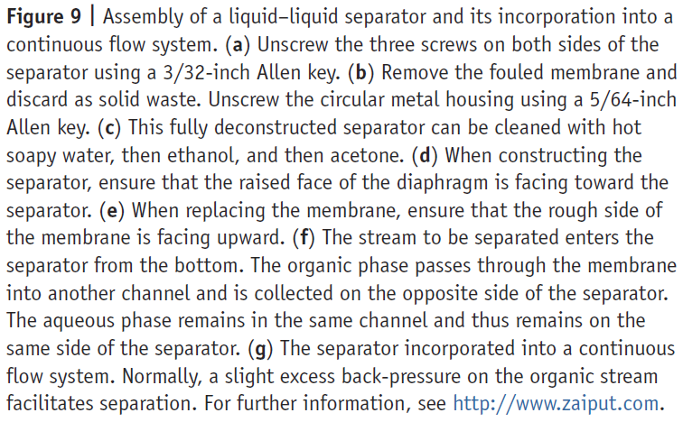

1. Run the system at several flowrates/mixer configurations

UNUSED INFORMATION. THIS IS MOSTLY THEORY, AND WILL EVENTUALLY BE INCORPORATED INTO THE CLASS MODULE.

PBR Theory

Use batch data to choose residence time.

Hints:

* When selecting batch kinetics, ensure they are intrinsic kinetics, not lumped (mass transfer/mixing-limited, etc.)
* Flow works best for times <30 min.
* Longer flows take longer to stabilize (3-10x residence time)
* Flow systems are often faster because they remove transport limitations

1. Choose flowrate (), mass loading (), reactor length (), and pressure () for flow to match batch conversion
   1. Design Heuristic: Residence Time

Definition: residence time is the average time a molecule spends within the reactor. It is analogous to batch ‘reaction time.’

Mathematically, for a simple single-phase incompressible fluid it is defined as:

Where is the interstitial void fraction, is the volume of the empty reactor (no packing), is the fluid flowrate. For a tubular geometry, the volume of a cylinder is used to describe as the volume of a tube with inside diameter and length, .

* 1. Given the residence time from Task 1 (1 min), choose suitable flowrate and reactor.

Sample Calculation: target of 1 minute residence time using a 2.1 x 10 mm tube and 150-180 um particles, assuming moderate packing (0.35) and glass beads ().

Note: the size and density of the particles was not needed here.

* 1. Determine how much mass of packing you should need

Note: this is the same mass for all the options (same tau so same VR so same amount of solids)

Hints:

* See Appendix A for hardware sourcing examples
* To avoid errors, use cm, cm3 = mL, and minutes for all terms
* Residence time is not a function of packing size ()
* Void fractions of tight or loose packed beds are 35-40% and 30-35%, respectively
* When choosing packing, make sure that particle sized are < 10% of tube ID, but not smaller than frit pore size.
* Smaller has better mixing and higher surface area, but larger pressure drop

Example Solutions:

|  |  |  |  |  |
| --- | --- | --- | --- | --- |
|  | F  (ml/min) | (cm) | (cm) | (min) |
| Option 1 | 0.12 | 10 | 0.21 | 1.0 |
| Option 2 | 0.01 | 1 | 0.21 | 1.0 |
| Option 3 | 58.16 | 10 | 4.6 | 1.0 |
| Option 4 | 5.82 | 1 | 4.6 | 1.0 |

* 1. Estimate anticipated reactor pressure

Pressure is required to induce flow and to keep reactants in the liquid phase (e.g. gas solubility or phase change). Each component in the system provides a pressure drop that can be estimated.

Example: A flow system is comprised of a pump, tubular preheater (5 m, 1/8” OD x 1.55 mm ID), a packed bed reactor (Option 2 above), a BPR set to just above the vapor pressure of toluene at 200 C (10 bar, see Appendix B). What pressure should the pump be able to provide?

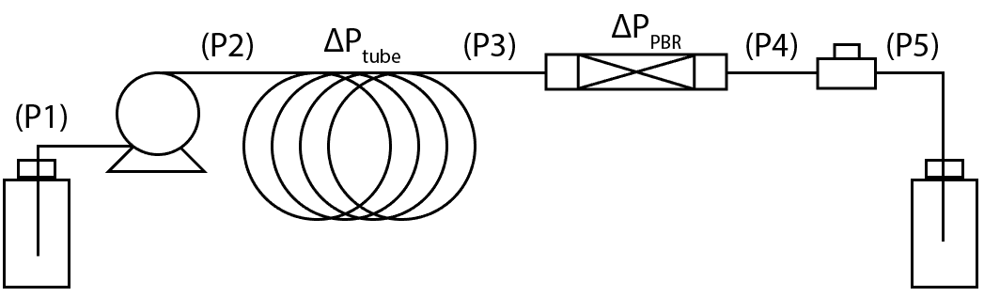

Step 1: Calculate using Darcy-Weisbach

Where is the fluid density, is the fluid velocity, is the Fanning friction factor, is the length of the tube and is the internal diameter.

so laminar flow regime. Fanning friction factor is in this regime.

Step 2: Calculate pressure drop across packed bed using the Ergun equation

where is the dynamic viscosity, is the density of the fluid. The diameter particles are in diameter and the bed is in length. The superficial velocity of the fluid is .

Step 3: Using those pressure calculate P1 – P5

P5 = 1 bar (atmospheric pressure)

P4 = 10 bar (BPR setpoint)

P3 = P4 + = 10 + 0.0207 = 10.0207 bar

P2 = P3 + = 10.0207 + 0.005 = 10.0212 bar

P1 = 1 bar (atmospheric)

Hints:

* Start with known pressure (P5) and work backward.
* Pressure is needed to design (1) materials of construction, (2) pump selection, (3) design/release safety valves, (4) provide knowledge of the reaction conditions (phase, solubility).
* Polymer tubing (PFA, PTFE) has lower temperature/pressure limits
* Each component has a pressure rating (e.g. flangeless ~500 psi, super-flangeless ~2500 psi, stainless ~20,000 psi)

1. Construct, pack and wash the reactor
   1. Design: Hardware

HPLC columns, prep columns, or custom-built tubing/compression systems can all be used. Here are some commercial options from IDEX (see Appendix A for additional design options)

Additionally, packing can be inert (glass spheres/sand) or reactive (solid reactants, catalysts). Here commercially available glass beed sizes are considered.

|  |  |
| --- | --- |
| **Packed Beds**  **ID (mm) x L (mm)** | **Packing (um)** |
| 2.1 x 30 | 355-425 |
| 2.1 x 50 | 300-355 |
| 2.1 x 100 | 150-180 |
| 2.1 x 150 | 90-106 |
| 2.1 x 200 | 75-90 |
| 2.1 x 250 | 63-75 |
| 3.2 x 100 |  |
| 4.6 x 100 |  |

Confirm the following are within temperature and pressure ratings

1. Vici M6HP Pump
   1. 1 ml/min, 10 bar, 20 C is okay
   2. Pmax = 1500 psi, Fmax = 5 mL/min
2. 1/8” PFA Tubing, 0.003” ID
   1. Pmax = , Tmax =
3. Fittings: flangeless (or superflangeless) IDEX
4. Stainless Steel PBR
   1. Pmax = , Tmax =
   2. Follow the procedure of Britton and Jamison, 2017 Step 51B to construct and fill the PBR tube.



1. Assemble the system (pumps, back pressure relief valve, pressure transducers, UV)



1. Performs ΔP study at 5 flowrates
   1. Experiment: see CHE4402 procedure

In brevity, set the liquid flowrate and record the pressure drop (LabVIEW). Repeat this for the following flowrates:

F=0.01, 0.05, 0.1, 0.5, 0.25, 0.5, 0.75, 1.0, 2.0, 3.0, 4.0, 5.0 ml/min

Note: wait for flowrate to stabilize

1. Perform RTDs at 3 flowrates
   1. Experiment: see CHE4402 procedure

In brevity, add the valve and RTD to the system and inject dye

F = 0.01, 0.1, 1.0 ml/min

Appendix A: PBR Hardware Design

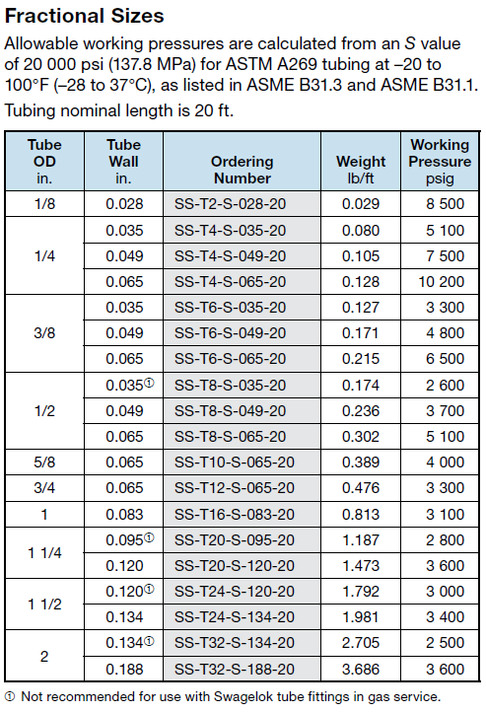

<https://www.swagelok.com/downloads/webcatalogs/en/MS-01-181.pdf>

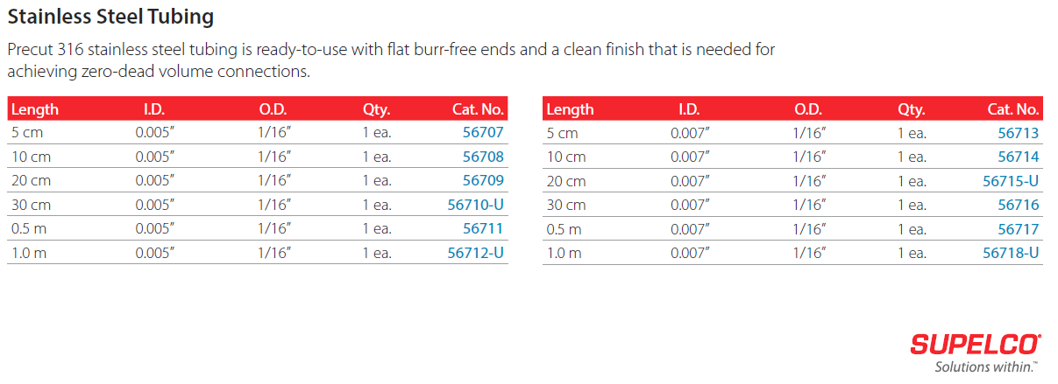

<https://www.sigmaaldrich.com/insite_t411058>

Appendix B: BPR Theory

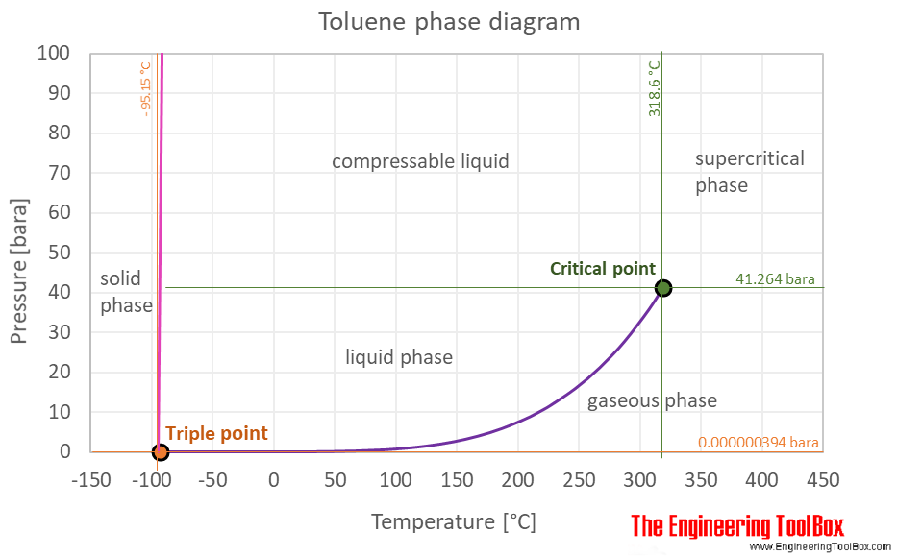

<https://www.engineeringtoolbox.com/toluene-methylbenzene-properties-d_2095.html>

Appendix C: PBR Theory

Tasks: Module 4 Theory

1. Choose residence time, temperature (from batch data)
   1. Batch kinetic screens can be used to identify operating regimes. The data below is simulated kinetic data for the following case:

Where B is the desired product and C is the over-reacted undesired product.

User Selection Options:

Zone 1 (10 s) – conversion is low (2%), but selectivity to B is extremely high

Zone 2 (60 s) – conversion is moderate (60%), with high selectivity (98%)

Zone 3 (1000 s) – conversion is quantitative, approaching thermodynamic product distribution, low selectivity (27%)

Hints:

* When selecting batch kinetics, ensure they are intrinsic kinetics, not lumped (mass transfer/mixing-limited, etc.)
* Flow works best for times <30 min.
* Longer flows take longer to stabilize (3-10x residence time)
* Flow systems are often faster because they remove transport limitations

1. Choose flowrate (), mass loading (), reactor length (), and pressure () for flow to match batch conversion
   1. Design Heuristic: Residence Time

Definition: residence time is the average time a molecule spends within the reactor. It is analogous to batch ‘reaction time.’

Mathematically, for a simple single-phase incompressible fluid it is defined as:

Where is the interstitial void fraction, is the volume of the empty reactor (no packing), is the fluid flowrate. For a tubular geometry, the volume of a cylinder is used to describe as the volume of a tube with inside diameter and length, .

* 1. Given the residence time from Task 1 (1 min), choose suitable flowrate and reactor.

Sample Calculation: target of 1 minute residence time using a 2.1 x 10 mm tube and 150-180 um particles, assuming moderate packing (0.35) and glass beads ().

Note: the size and density of the particles was not needed here.

* 1. Determine how much mass of packing you should need

Note: this is the same mass for all the options (same tau so same VR so same amount of solids)

Hints:

* See Appendix A for hardware sourcing examples
* To avoid errors, use cm, cm3 = mL, and minutes for all terms
* Residence time is not a function of packing size ()
* Void fractions of tight or loose packed beds are 35-40% and 30-35%, respectively
* When choosing packing, make sure that particle sized are < 10% of tube ID, but not smaller than frit pore size.
* Smaller has better mixing and higher surface area, but larger pressure drop

Example Solutions:

|  |  |  |  |  |
| --- | --- | --- | --- | --- |
|  | F  (ml/min) | (cm) | (cm) | (min) |
| Option 1 | 0.12 | 10 | 0.21 | 1.0 |
| Option 2 | 0.01 | 1 | 0.21 | 1.0 |
| Option 3 | 58.16 | 10 | 4.6 | 1.0 |
| Option 4 | 5.82 | 1 | 4.6 | 1.0 |

* 1. Estimate anticipated reactor pressure

Pressure is required to induce flow and to keep reactants in the liquid phase (e.g. gas solubility or phase change). Each component in the system provides a pressure drop that can be estimated.

Example: A flow system is comprised of a pump, tubular preheater (5 m, 1/8” OD x 1.55 mm ID), a packed bed reactor (Option 2 above), a BPR set to just above the vapor pressure of toluene at 200 C (10 bar, see Appendix B). What pressure should the pump be able to provide?



Step 1: Calculate using Darcy-Weisbach

Where is the fluid density, is the fluid velocity, is the Fanning friction factor, is the length of the tube and is the internal diameter.

so laminar flow regime. Fanning friction factor is in this regime.

Step 2: Calculate pressure drop across packed bed using the Ergun equation

where is the dynamic viscosity, is the density of the fluid. The diameter particles are in diameter and the bed is in length. The superficial velocity of the fluid is .

Step 3: Using those pressure calculate P1 – P5

P5 = 1 bar (atmospheric pressure)

P4 = 10 bar (BPR setpoint)

P3 = P4 + = 10 + 0.0207 = 10.0207 bar

P2 = P3 + = 10.0207 + 0.005 = 10.0212 bar

P1 = 1 bar (atmospheric)

Hints:

* Start with known pressure (P5) and work backward.
* Pressure is needed to design (1) materials of construction, (2) pump selection, (3) design/release safety valves, (4) provide knowledge of the reaction conditions (phase, solubility).
* Polymer tubing (PFA, PTFE) has lower temperature/pressure limits
* Each component has a pressure rating (e.g. flangeless ~500 psi, super-flangeless ~2500 psi, stainless ~20,000 psi)